## **Example taken: Cloudfare.com**

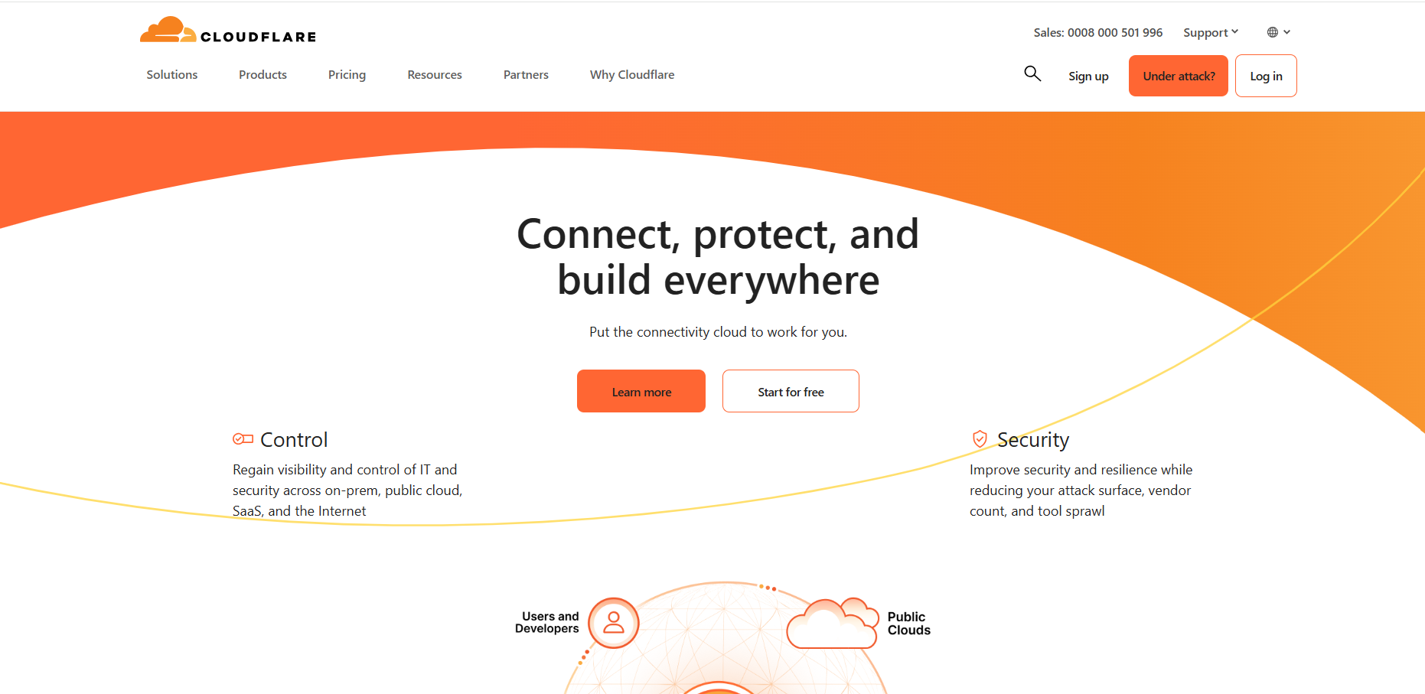

## **Source Code:**

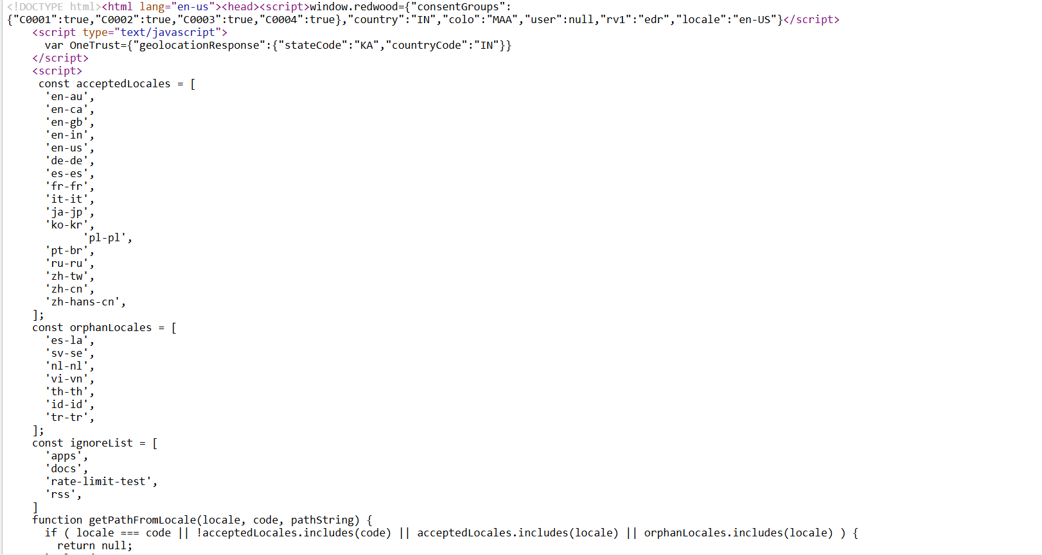

**Meta tag:** The <meta> tags provide metadata about the webpage, including information like character encoding, author, description, viewport settings, and social media previews

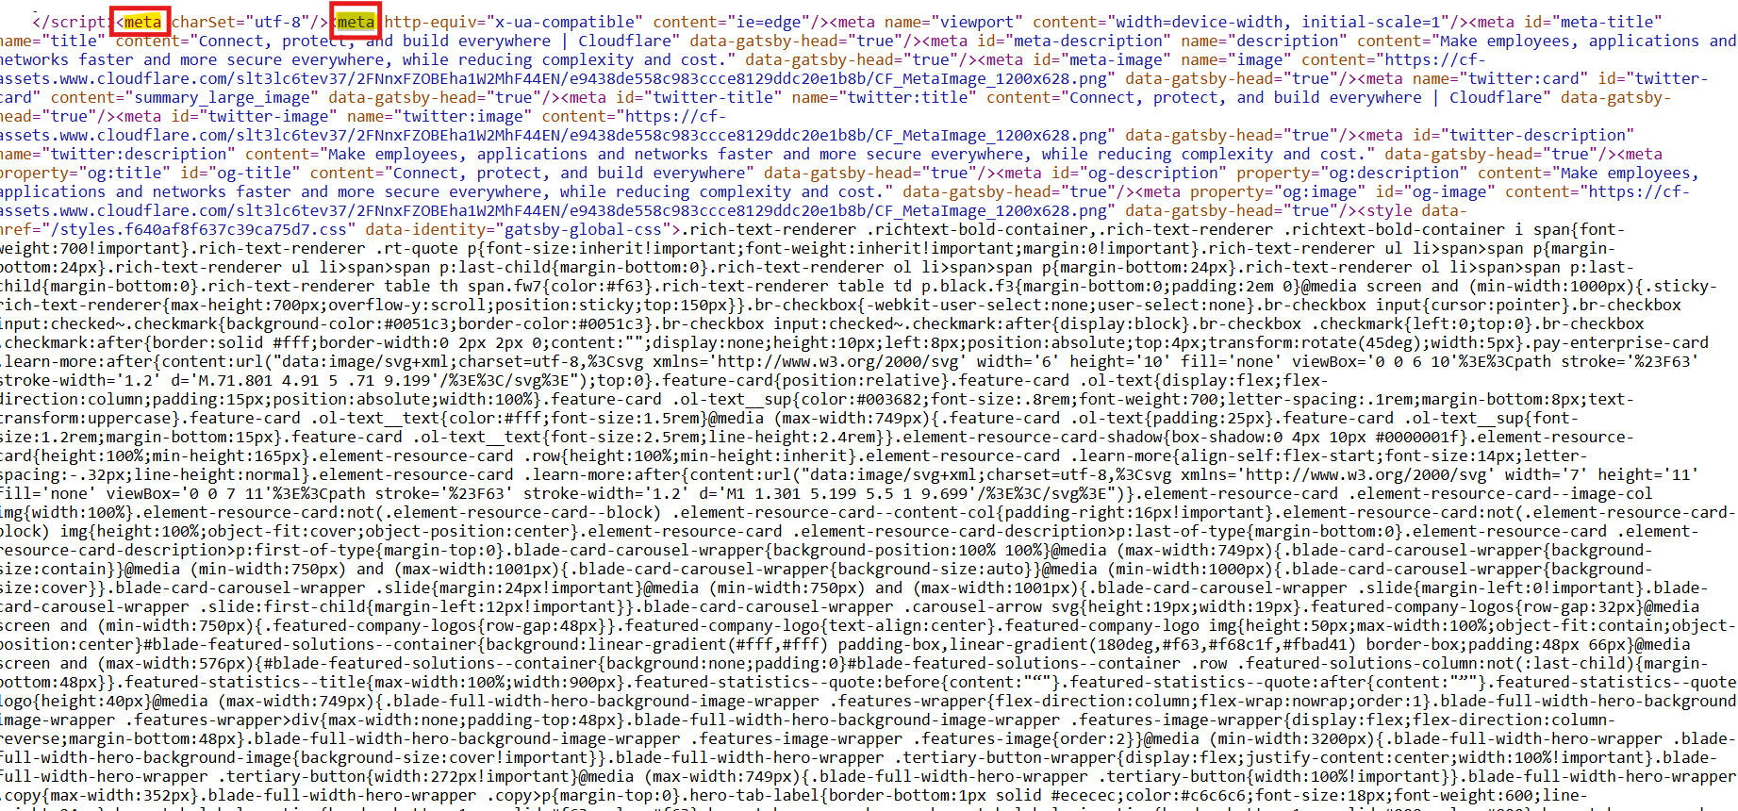

**Heading tag (h1,h2):** This defines the headings in the document or webpage

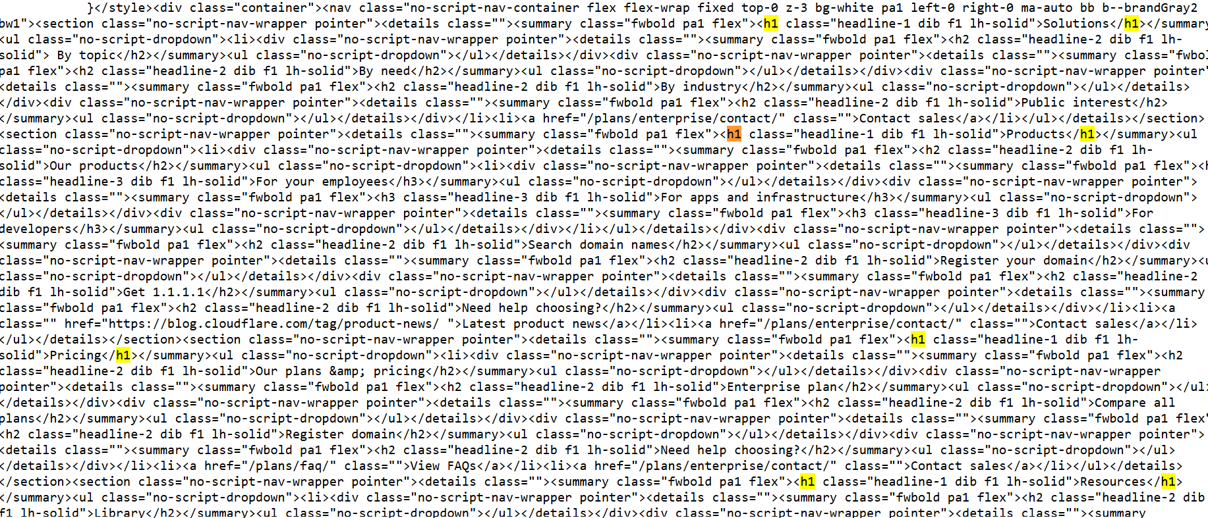

**Multimedia elements:** <iframe> is used to embed external content like another webpage, a map, or a video from services like YouTube.

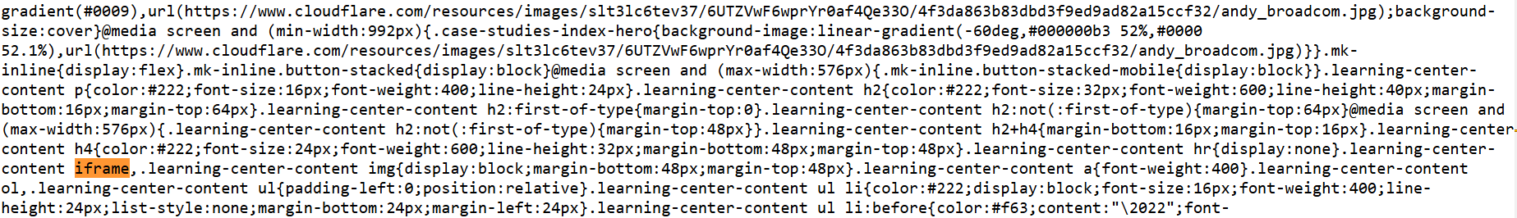

**Security related tags:**

SRI (Subresource Integrity): This attribute ensures that external resources (like scripts or stylesheets) haven't been tampered with. The integrity attribute contains a hash value of the file. If the file has been altered, the browser will refuse to load it.

